**Group 7 ETL Project Report**

**EXTRACT:**

The premise of our ETL project take a movie dataset that contained three decades of movie data from 1986-2016 from Kaggle (<https://www.kaggle.com/danielgrijalvas/movies?select=movies.csv>) and build upon it with another set of data. The original Kaggle data set contained 15 columns of information, but regarding box office revenue it only contained the domestic box office revenue. We decided that our second source of data should have the international or total box office revenue for each movie so we could merge that data into our .csv downloaded from Kaggle (movies.csv). We created a for loop to web scrape the total (domestic + international) box office revenue for 10,000 movies from Box Office Mojo ([https://www.boxofficemojo.com/chart/top_lifetime_gross/?area=XWW).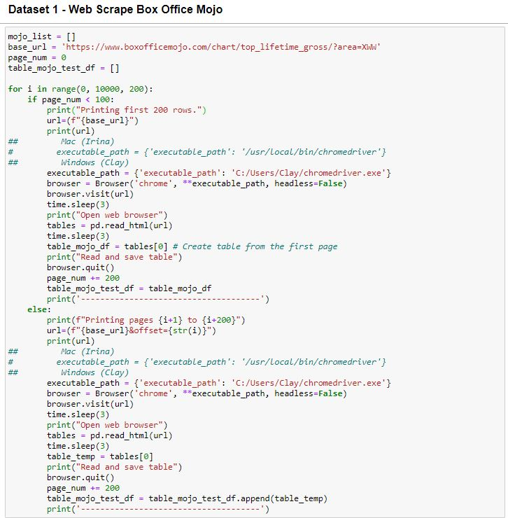](https://www.boxofficemojo.com/chart/top_lifetime_gross/?area=XWW).)

Note that the loop code needs to be adjusted for Mac or Windows users, and the location of your chromedriver.exe path.

**TRANSFORM:**

We then cleaned our data inside the scrape_final.ipynb file and prepared it for export into SQL. This involved dropping any duplicate data, changing datatypes of certain columns into integer or datetime format, and much more organizational steps. Instructors or graders of this project will need to run the scrape_final.ipynb file from top to bottom. Instructions are included in the file, along with all steps taken to clean the data.

Duplication Drop Preparation:

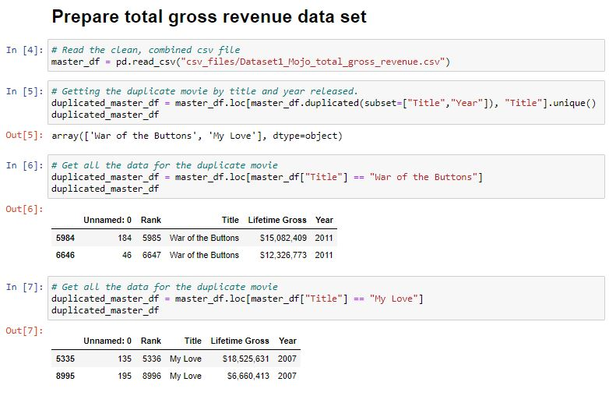

Currency to Numeric:

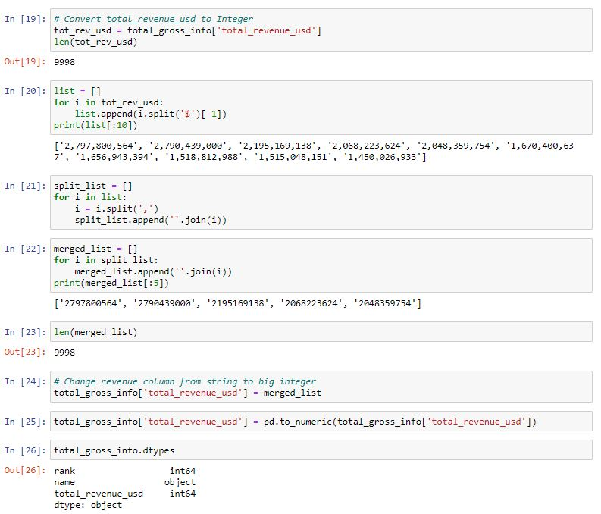

The movies without string matches (2362/7040) had null values that we had to convert to numeric 0 for sorting later on (because when sorted in DESC order, Null appears on top).

Part of the data preparation and transformation is to do a **Left join** on the two tables since we are only concerned about expanding our original Kaggle dataset with movies from 1986-2016 (The data that was scraped from Box Office Mojo contains 10,000 movies, some of which are before 1986 and after 2016) to create a combined_gross_info table. Since we have gathered data for domestic & total box office revenue for each movie, we can now calculate the international box office revenue. The SQL code will look as follows:

Extraction to SQL example:

We also created an ERD to give us a template of how we were going to prepare our data in SQL. This creates the foundation for the project moving forward. The ERD looks as follows:

Please follow the steps below:

* Run ETL_final.ipynb file. Note: correct chromedriver locations should be selected (Mac/Win)
* Note: code will stop before pushing the tables to PostgreSQL.

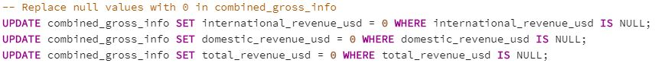

We then dropped columns that weren’t necessary for our project and sorted the movies based on total_revenue_usd (Global Box Office Revenue) in one step, and saved the new table as ‘movies’.

Afterwards, we added Primary Keys to all our tables and defined our Foreign Keys.

**Load:**

In PostgreSQL, import QuickDBD-export.sql file.

Run the entire script

Our database is movies_dB which contains the following tables:

* Movies
* Director
* Actor
* Writer
* Company
* Genre
* Rating
* Actor_Movie
* Director_Movie
* Company_Movie

The actor_movie, director_movie, and company_movie tables are in place to connect the actor, director, and company tables to the movies table (main table). One idea we were going to implement was rank columns for actors, directors, and companies. The rank would be determined by sum of the actors, directors, or companies total_revenue_usd. Unfortunately, we were restricted on time and this would surpass the ETL process, but gives a good idea of where how the foundation of our data could be used.